Floating-point arithmetic using a neuromorphic chip

Arun M George, Rahul Sharma
IIIT Bangalore

Problem statement – To come up with a design and implementation for carrying out floating-point arithmetic (IEEE 754) computation using a neuromorphic chip.

Floating-point arithmetic has its applications in scientific computations, especially where high precision computations are needed. Floating-point numbers in IEEE 754 format consist of three fields: a sign bit, a biased exponent, and a fraction.

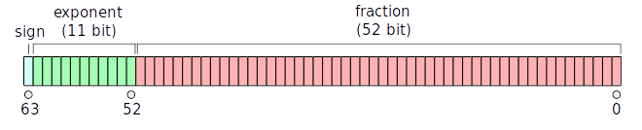
Fig 1: The three fields in a 64bit IEEE 754 float
Approach - We’ll use the Nengo library for designing the neural groups and connections between them for doing floating-point arithmetic as shown below in fig. 2. In the figure, input_node_1 and input_node_2 are used to simulate the two input floating point number values, these two values are then represented by a group of neurons in two_dim_ensemble. Then the connection between two_dim_ensemble and output_ensemble computes the fuction (add/subtract). The number of neurons in an ensemble and the connections between them impacts the accuracy of the floating-point computation (as shown in fig. 3). So our research will be focused on coming up with a design that would have lower errors for all the floating-point operations.

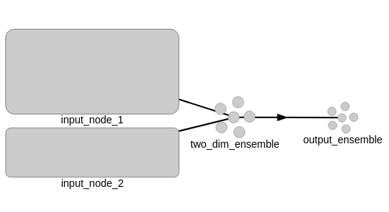
Fig. 2: A design with two ensembles where the two_dim_ensemble has 220 neurons and the output_ensemble has 100 neurons

As shown in the fig 2, each ensemble has two parameters - number of neurons and dimension which define the structure of the entire model.
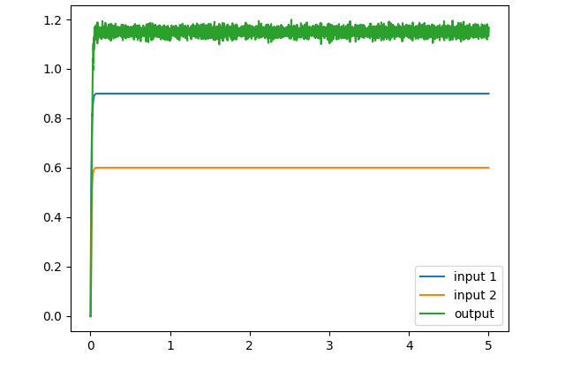
Fig. 3: Addition of 0.6 and 0.9 leads to a significant error with the design shown above

We will follow two approaches (for addition initially) – one involves performing the operation on two floating point numbers in whole i.e. the complete number whereas the other involves performing the computation on one digit at a time and then cascading the result. Performing the computation one digit at a time will be slower whereas the other approach will lead to a more bulky model which will require more neurons. We’ll compare the result of both approaches and then apply the same approach to other operations. We’ll start with a model to add two single digit numbers using the Leaky integrate-and-fire model and then extend it to add/subtract any floating point number. Here we’ll try both the approaches as mentioned above, compare the results and choose one of them. Then we’ll try different spiking neuron models (Integrate and fire, Quadratic I and F, FitzHugh–Nagumo) to see its impact on accuracy. Finally, we’ll integrate the model.

Milestones -

- 23 August – Come up with a design to add two single digit numbers using the Leaky integrate-and-fire model

- 13 September – Extend the earlier design to add/subtract any floating point number. Try both approaches – one-time computation (perform the operation on complete numbers) vs cascading computation (perform the operation on one digit at a time) using IEEE 754

- 4 October – Try different spiking neuron models (Integrate and fire, Quadratic I and F, FitzHugh–Nagumo) for impact on accuracy

- 11 October – Integrate all models

- 18 October – Final report

